📘 Assignment: Networking Technologies

🔹 Task 1: Network Diagram – Smartphone Connecting to Instagram
Answer:
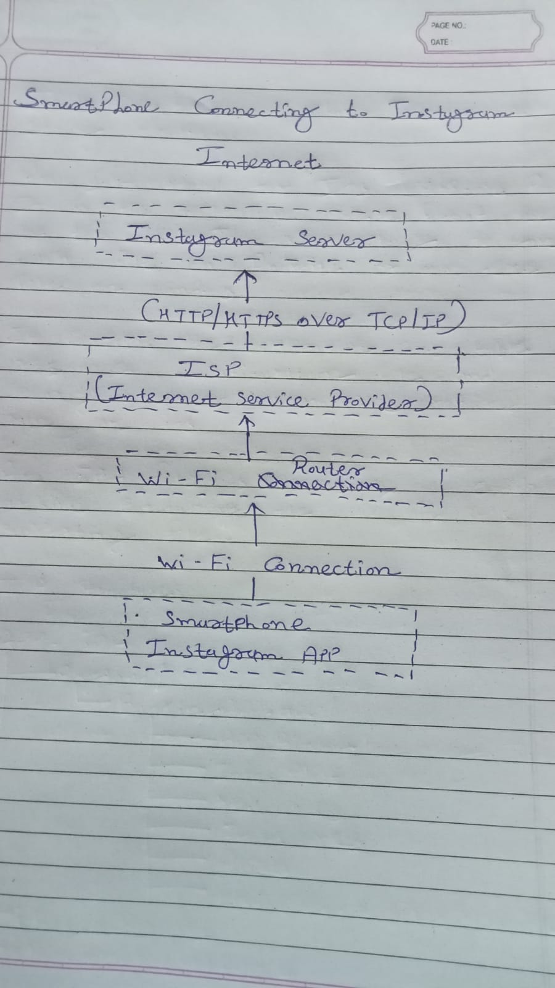
Task 2: Display IP Address and Default Gateway
Windows Command
Ipconfig
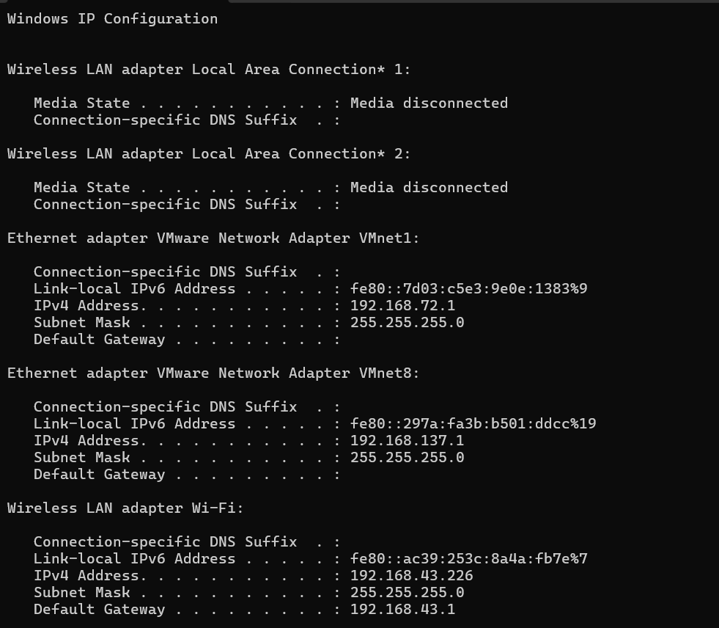

Task 3: Zomato Food Order Journey
Answer:
When a user places an order on Zomato, the following steps occur:
- The user opens the Zomato app on the smartphone.
- The app sends a DNS request to translate the domain name (e.g., zomato.com) into an IP address.
- The DNS server responds with the IP address of Zomato's server.
- The device establishes a connection using the TCP/IP protocol.
- The app sends an HTTPS (HTTP Secure) request to the Zomato server.
- The server processes the request and retrieves restaurant information.
- The restaurant list is sent back to the user's device.
- The user selects a restaurant and places an order.
- The order details are securely transmitted to the server using HTTPS over TCP/IP.
- The server forwards the order to the selected restaurant.
- The restaurant confirms the order.
- The confirmation is sent back through the internet to the user's device, where the order status is displayed.
Protocols Used
Protocol | Purpose
DNS | Converts the website name into an IP address.
TCP/IP | Ensures reliable communication between the device and server.
HTTPS | Encrypts the communication and protects sensitive information.

🔹 Task 4: Test Connectivity Using ping
Command
ping www.spotify.com
